Digital Pirani Vacuum Gauge – DPRG-2GH-SP
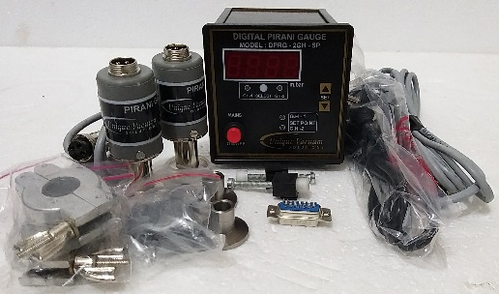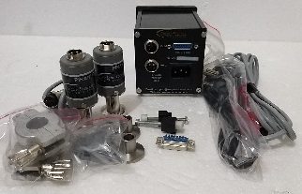
The UVS Model DPRG series Vacuum Pirani Gauge Controller displays vacuum pressure as measured from a S-PR-GH sensor tube. It displays vacuum measurements based on thermal conductivity of gases. The Model DPRG-2GH-SP unit covers the range from 0.001 mbar to 20 mbar, and controls relay with independent set point.
It is a dual channel gauge, channel selection from front bezel membrane switch.
TECHNICAL SPECIFICATIONS
Number of sensor channels | TWO
Display Range | 1000 mBar to 0.001mBar.
Measuring Range | 20 mBar to 0.001mBar.
Units of Display | m.Bar
Vacuum Gauge Head | S-PR-GH sensor tube
Temp. Range | +2 to +50 deg. Celsius
VAC. Display | 4-digit bright red LED, 14 mm high
Channel selection | Through front panel selection switch
VAC and ATM Adjust | adjusted by trim pot at the signal conditioner PCB.
Process control set points | Two
Process Control Relays | Two relays, potential free contacts; independent available through the DB15 accessory connector on the rear panel
Nonvolatile Memory | Only for set points
Operating Voltage | universal power supply, input voltages from 90 ~ 264VAC 50/60 Hz
Mounting | ¼ DIN 92 x 92 mm (3.62” x 3.62")
Environmental Considerations | not for use with explosive or corrosive gases
Overall dimensions | 92mm X 92mm X 110mm Depth
Optional outputs on request | RS485, 0 -10V Dc analog output
Features at a Glance
■ Measurement range 0.001 to 20 mbar ■ Space saving rugged design- 1/8 DIN console ■ Space saving rugged design- 1/8 DIN console ■ Mounts in any orientation ■ brass body measuring cell with metal-sealed feed through ■ with universal power supply – input voltage from 90 ~ 264VAC, frequency 47 ~ 440Hz
Applications
■ Controlling high vacuum systems ■ Fore vacuum pressure monitoring ■ Safety circuits in vacuum systems ■ General vacuum measurement & control in the fine and rough vacuum range.
Calibration:
Unique Vacuum Solutions offers a convenient recalibration service to help users of vacuum measurement pirani/ thermocouple/ full range gauges to maintain all of their vacuum gauges in Certified and peak condition, regardless of the original manufacturer. All makes of vacuum gauges can also be calibrated / repaired if required.
The calibration certificates are available only on request at additional cost. Pl contact before ordering.

UNIQUE VACUUM SOLUTIONS
#57, 8th cross, 1st B cross, Daddanna industrial area main raod, vishwaneedam post, Near Peenya 2nd stage, Bangalore -560091
Ph: 080-28367059, 9886726920. e mail: support@uniquevacuum.co.in, WEB: www.uniquevacuum.co.in

